Requirement Draft of self-publishing platform
1. Introduction
This project aims to develop a self-publishing platform for New Zealand authors.
The system will support authors in publishing their books through a simple and streamlined process. The platform is intended to provide an alternative to existing systems such as Amazon and Lulu, focusing on local authors and readers.

2. Stakeholders
- Authors: want to publish books easily and efficiently
- Readers: want access to affordable local books
- Entrepreneurs: want to build a competitive and scalable platform
- Writers’ groups: provide feedback and requirements

3. Functional Requirements
FR1: The system shall allow authors to upload manuscripts
FR2: The system shall provide editing and formatting tools
FR3: The system shall allow authors to publish books
FR4: Users shall be able to browse available books
FR5: Users shall be able to search for books
FR6: Users shall be able to purchase books online
FR7: The system shall support user account registration and login
FR8: Authors shall be able to update or delete their books

4. Non-functional Requirements
NFR1: The system should be easy to use for non-technical users
NFR2: The system should be available 24/7
NFR3: The system should support at least 1000 concurrent users
NFR4: The system should respond within 2 seconds
NFR5: The system should ensure secure payment processing

5. Constraints
- Limited technical expertise of the founders
- Budget limitations
- Competition from existing platforms such as Amazon and Lulu

6. Assumptions
- Users have access to the internet
- Authors have basic computer literacy
- Payment services can be integrated via third-party APIs

7.Use Case Specifications
Use Case 1: Publish Book:
Use Case Specification
Use Case Name: | Publish Book
Actors: | Author (primary), System (secondary)  Reader (primary), Payment Service (secondary)
Brief Description: | Allows an author to upload, edit and publish a book on the platform.
Priority: | Must have
Status: | Medium detail
Preconditions: | Author has a registered account  Author is logged in  Author has a manuscript file ready
Postconditions: | The book is stored in the system  The book becomes visible to readers
Basic Flow: | - Author logs into the platform  - Author selects “Create New Book”  - Author uploads the manuscript  - Author enters book details such as title, author name and description  - Author edits or formats the content if needed  - Author clicks “Publish”  - System validates the input data  - System stores the book in the database  - System makes the book available on the platform
Alternative Flows: | 3a. Unsupported file format  4a. Missing required book details  7a. Validation fails  8a. Database save fails
Business Rules: | B1: Only registered authors can publish books  B2: Only supported file formats may be uploaded  B3: Required metadata must be completed before publication
Non-Functional Requirements: | NF1: File upload should complete within 10 seconds for normal file sizes  NF2: Uploaded manuscripts must be securely stored  NF3: The publishing interface should be easy for non-technical users to understand
Use Case 2: Purchase Book:
Use Case Specification
Use Case Name: | Purchase Book
Actors: | Author (primary), System (secondary)  Reader (primary), Payment Service (secondary)
Brief Description: | Allows a reader to select and purchase a book online.
Priority: | Must have
Status: | Medium detail
Preconditions: | Reader has selected a book  Reader is logged in  Payment service is available
Postconditions: | Payment is recorded  Reader receives access to the purchased book  Order information is stored
Basic Flow: | - Reader logs into the platform  - Reader browses or searches for a book  - Reader selects a book  - Reader clicks “Buy”  - System shows the payment page  - Reader enters payment details  - Payment service validates the payment  - System confirms the purchase  - Reader receives access to the book
Alternative Flows: | 6a. Invalid payment details  7a. Payment declined  7b. Payment service unavailable  9a. Reader does not receive access successfully
Business Rules: | BR1: Only available books can be purchased  BR2: Payment must be completed before access is granted  BR3: Prices must be displayed in NZD
Non-Functional Requirements: | NF1: Payment processing must be secure  NF2: Purchase confirmation should be shown within 3 seconds after successful payment  NF3: The process should be simple and require minimal steps
8. Use Case Diagram (Draft)
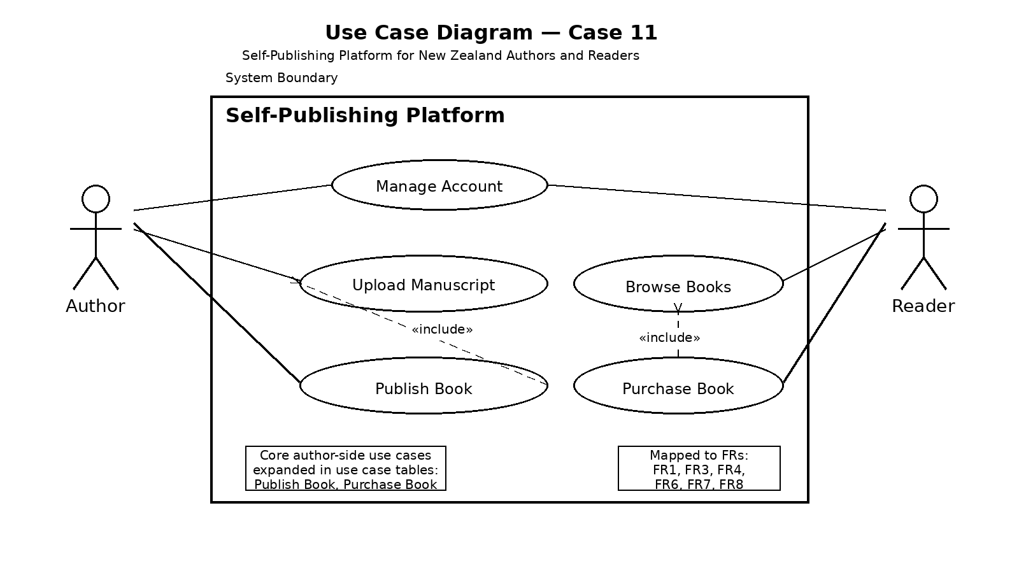
9. Sources of Requirements
- Project brief provided in coursework
- Interviews with writers’ groups
- Analysis of existing platforms such as Amazon and Lulu

